# **Dropout**

## **Ensemble Methods**

Does it make sense to rely on multiple models instead of a single one?

1. Ensemble methods are techniques that create multiple models and combine their outputs to produce improved results.
2. The outputs of the models are combined in various ways, such as averaging them, taking the weighted average etc.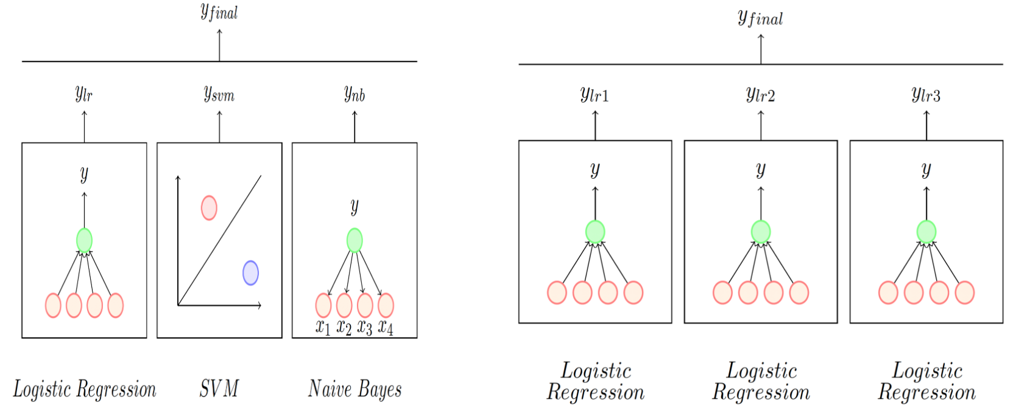
   1. The models used can be dissimilar: Combining a Logistic Regression model with an SVM and a Naive Bayes Classifier
   2. The modes can also be similar: Combining the output of 3 Logistic Regression classifiers each trained differently (different subsets of data/features or using different hyperparameters).
3. Now, let us look at how to apply ensemble methods to Neural Networks
   1. **Method 1**: Train different architectures(models) on the same data. **Computationally Expensive**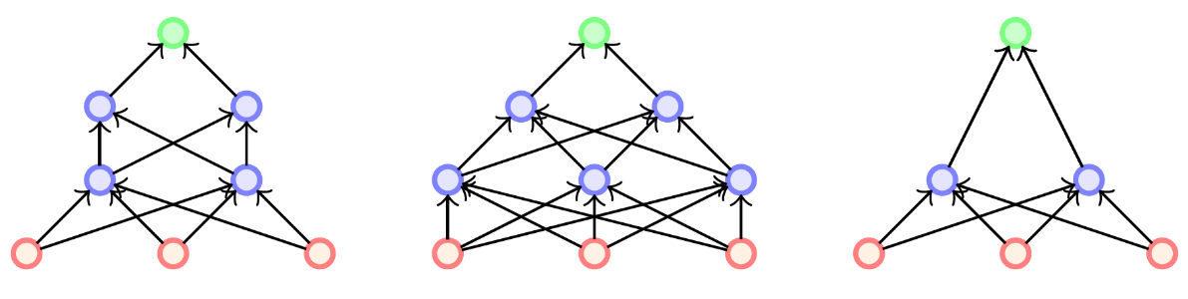
   2. Method 2: Train the same architecture on different training data subsets. **Computationally Expensive**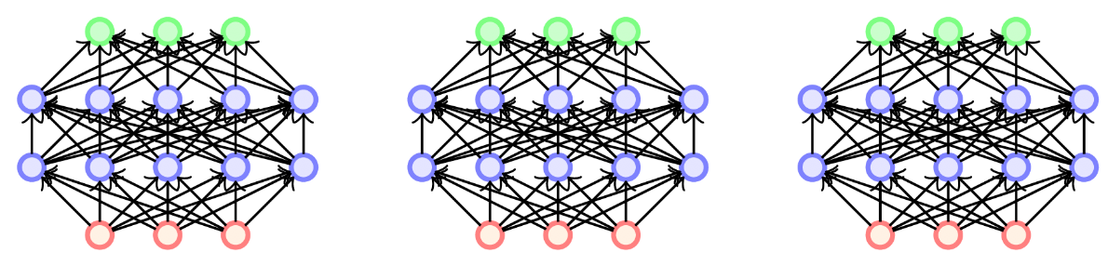
4. How do we create an ensemble method for Neural Networks that does not have a significantly large training time